**Name : Shahzadi Begum Shaikh Rafique**

**Subject : Assignment 4 CSharp**

Q. Create a custom exception class named StackException. The Push()and Pop() method should throw object of StackException when the stack is full or empty respectively.

using System;

using System.Collections.Generic;

using System.Linq;

using System.Text;

using System.Threading.Tasks;

namespace Assign4Exception

{

class StackException

{

static int MAX = 100;

int top = -1;

int[] Stack = new int[MAX];

int value;

public StackException()

{

top = -1;

}

public void Push(int data)

{

if (top == MAX - 1)

{

throw new Exception("Stack Overflow =");

}

else

{

Stack[++top] = data;

}

}

public int POP()

{

if (top == -1)

{

throw new Exception("Stack UnderFlow =");

}

else

{

value = Stack[top--];

return value;

}

}

public void PrintStack()

{

if (top == -1)

{

Console.WriteLine("Stack Is Empty");

return;

}

else

{

Console.WriteLine("Items in the Stack are :");

for (int i = top; i >= 0; i--)

{

Console.WriteLine(Stack[i]);

}

}

}

}

class Program

{

static void Main()

{

StackException myStack = new StackException();

myStack.Push(10);

myStack.Push(20);

myStack.Push(30);

myStack.Push(40);

myStack.PrintStack();

// Console.WriteLine("Item popped from Stack : {1}", myStack.POP());

myStack.POP();

myStack.POP();

myStack.POP();

myStack.POP();

myStack.PrintStack();

Console.ReadKey();

}

}

}

**OutPut**

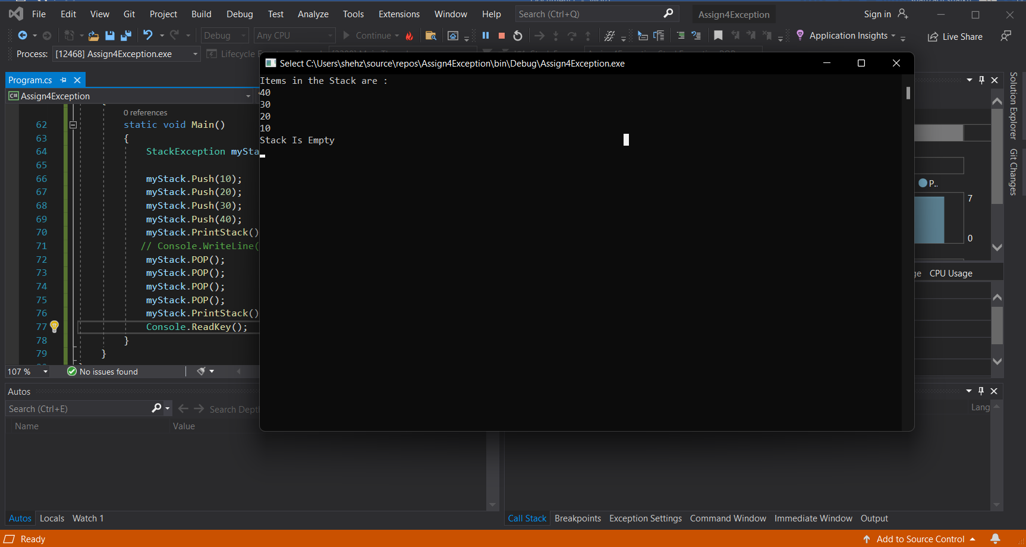

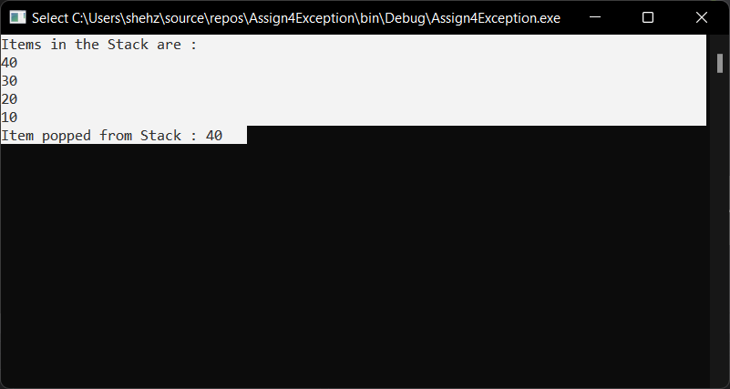

**Stack Under Flow Exception**

